Experiment # 02

**Studying internal components of a system**

**Objective**

1. Viewing internal components of a computer system.

2. Plug in power cables, data cables of the system.

3. Attaching RAM, cards, I/O components on the motherboard.

4. Practice on Typing Tutor

**Theory**

* + - 1. **Processor:**

The processor unit inside the computer is one of the most vital components that must be used and installed properly for the computer to work. The processor carries out all the main procedures the computer. A Processor is also known as a Central Processing Unit or CPU for short.

The processor on a home PC is often contained or housed inside a silicon packet or shell to protect it, although you should still take care when handling a processor.

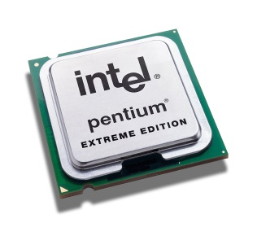

* + - 1. **Motherboard:**

The motherboard is the heart of the computer, without it the computer would not work. The motherboard, hence its name is the mother of the computer, it connects all the other components together to make the computer run. The motherboard contains slots, slots for the Graphics card, network cards, RAM cards and other major components to the computer.

The motherboard connects other major components together like the Hard Drive and CD-ROM. On the motherboard itself it has ports, which allow you to plug in your USB devices, audio jacks and other plug in valuables you may have.

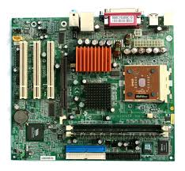

* + - 1. **BIOS (Basic Input/output System):**

The BIOS on the computer is like the brain, it contains all the visual setting to make the computer run. You can specify what hard drive to run the operating system off, you can change the time and date and so much more, without the BIOS, you wouldn’t be able to diagnose problems with the computer as fast and efficiently as you can with it.

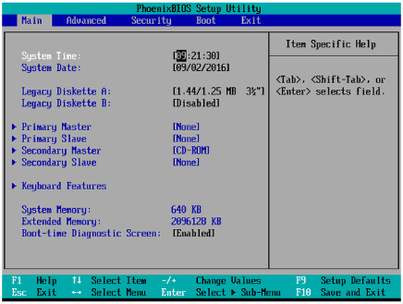

* + - 1. **Power Supply:**

The power supply maintains all of the power coming in and out of the computer, keeping the right voltage while cooling the computer down at the same time. The power supply, when all connected up properly provides power to the computer, if something went wrong, like it broke; there would be no power going to the computer. The Power supply also has fans to keep the computer cool when in use.

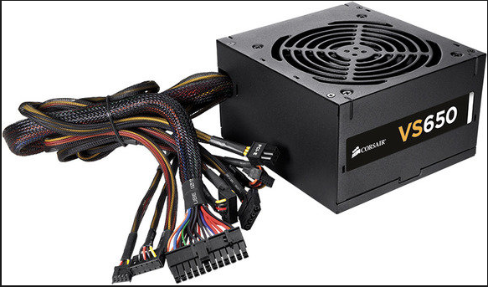

* + - 1. **Fan and cooling unit:**

Fan and cooling systems are one of the most essential parts of a computer’s system. Without fans and cooling systems your computer would produce so much heat it would overheat and die. The fans prevent this from happening by pushing cool air into the computer, keeping it cool. The more fans you have the higher chance you have of not overheating. You can also get systems like water coolers, which can cool your computer down a considerable amount. Obviously having an open fan can attract dust and dirt to the computer, so be sure to clean the computer regular and keep on top of dust and dirt.

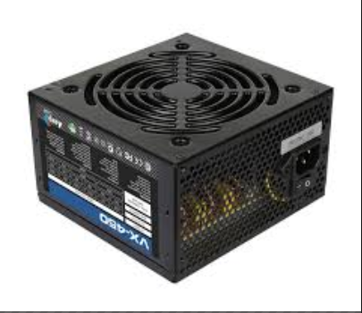

* + - 1. **Ports including, USB, Parallel and serial**

Ports enable you to plug in devices that may be needed on your computer, for example, your mouse and keyboard. These ports are called USB Ports; you also have ports for other connections like your webcam.

These ports are located at the back of your computer, it may look strange at first but you know what they all do when you start looking at them. Other port on the back of the computer, like the display port is obviously used to display the computers system on a monitor, this port allows a cable called the ‘VGA’ cable to go into it.

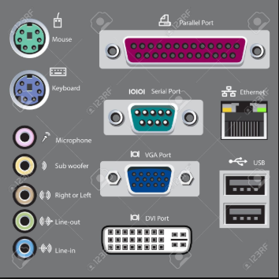 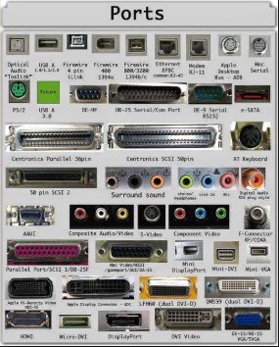

* + - 1. **Internal memory**

Inside the computer, you have certain parts that contain some of the most vital information needed for a computer to run, these are called RAM’s. A RAM is a rectangle piece of component that is one of the computers storage devices.

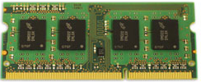

* + - 1. **Internal cards, Including Network and Graphics card**

Graphics cards are the things that most people need that use their computer day to day. A graphics card enables you to do many things, like multi-monitor, this is where you have two or more monitors connected to your computer and you can see with those screens. Without a graphics card you couldn’t do this. A graphics card also enables the computer to improve the graphics of 3D Environments, as for games and other things you may be looking at. As simple as it may sound, the graphics cards also offer you MPEG-2/MPEG-4 decoding so that you can preview those sorts of videos.

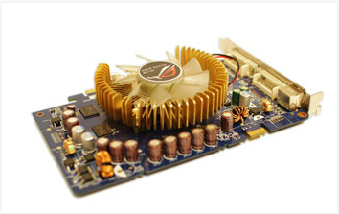

Network cards do a lot. A network card allows you to connect to the internet via a LAN cable, which the Network card contains, the connection to input a cable to it. You can also get network cards that allow you to preview television, so you plug your Arial into the network card, which is fitted on your computer and then preview the television.

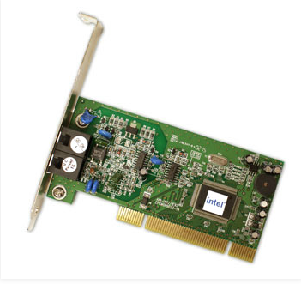

**Lab Tasks**

1. List 10 features (In bullets) of 10 internal components and ports of a system.
2. Plugging in the power and data cables of all I/O devices accordingly and writing a practical learning report.
3. Install typing tutor in your system, register with your registration number and practice 2 lessons and add 10 different practice screenshots.

**Conclusion**

**________________________________________________________________________________________________________________________________________________________________________________________________________________________________________________________**